**Overview of the Analysis**

We were tasked by using the nonprofit organization name Alphabet Soup to create a tool that will help select funding applicants with the best chance to be successful. Do to so, we were using our knowledge on neural network to predict whether or not the applicant will be successful.

First, we use the features in the dataset that was provided to create a binary classifier. (Preprocess the data)

We did clean our dataset by dropping the unnecessary columns

We did identify our target for the model and identified which variable are the feature for our model

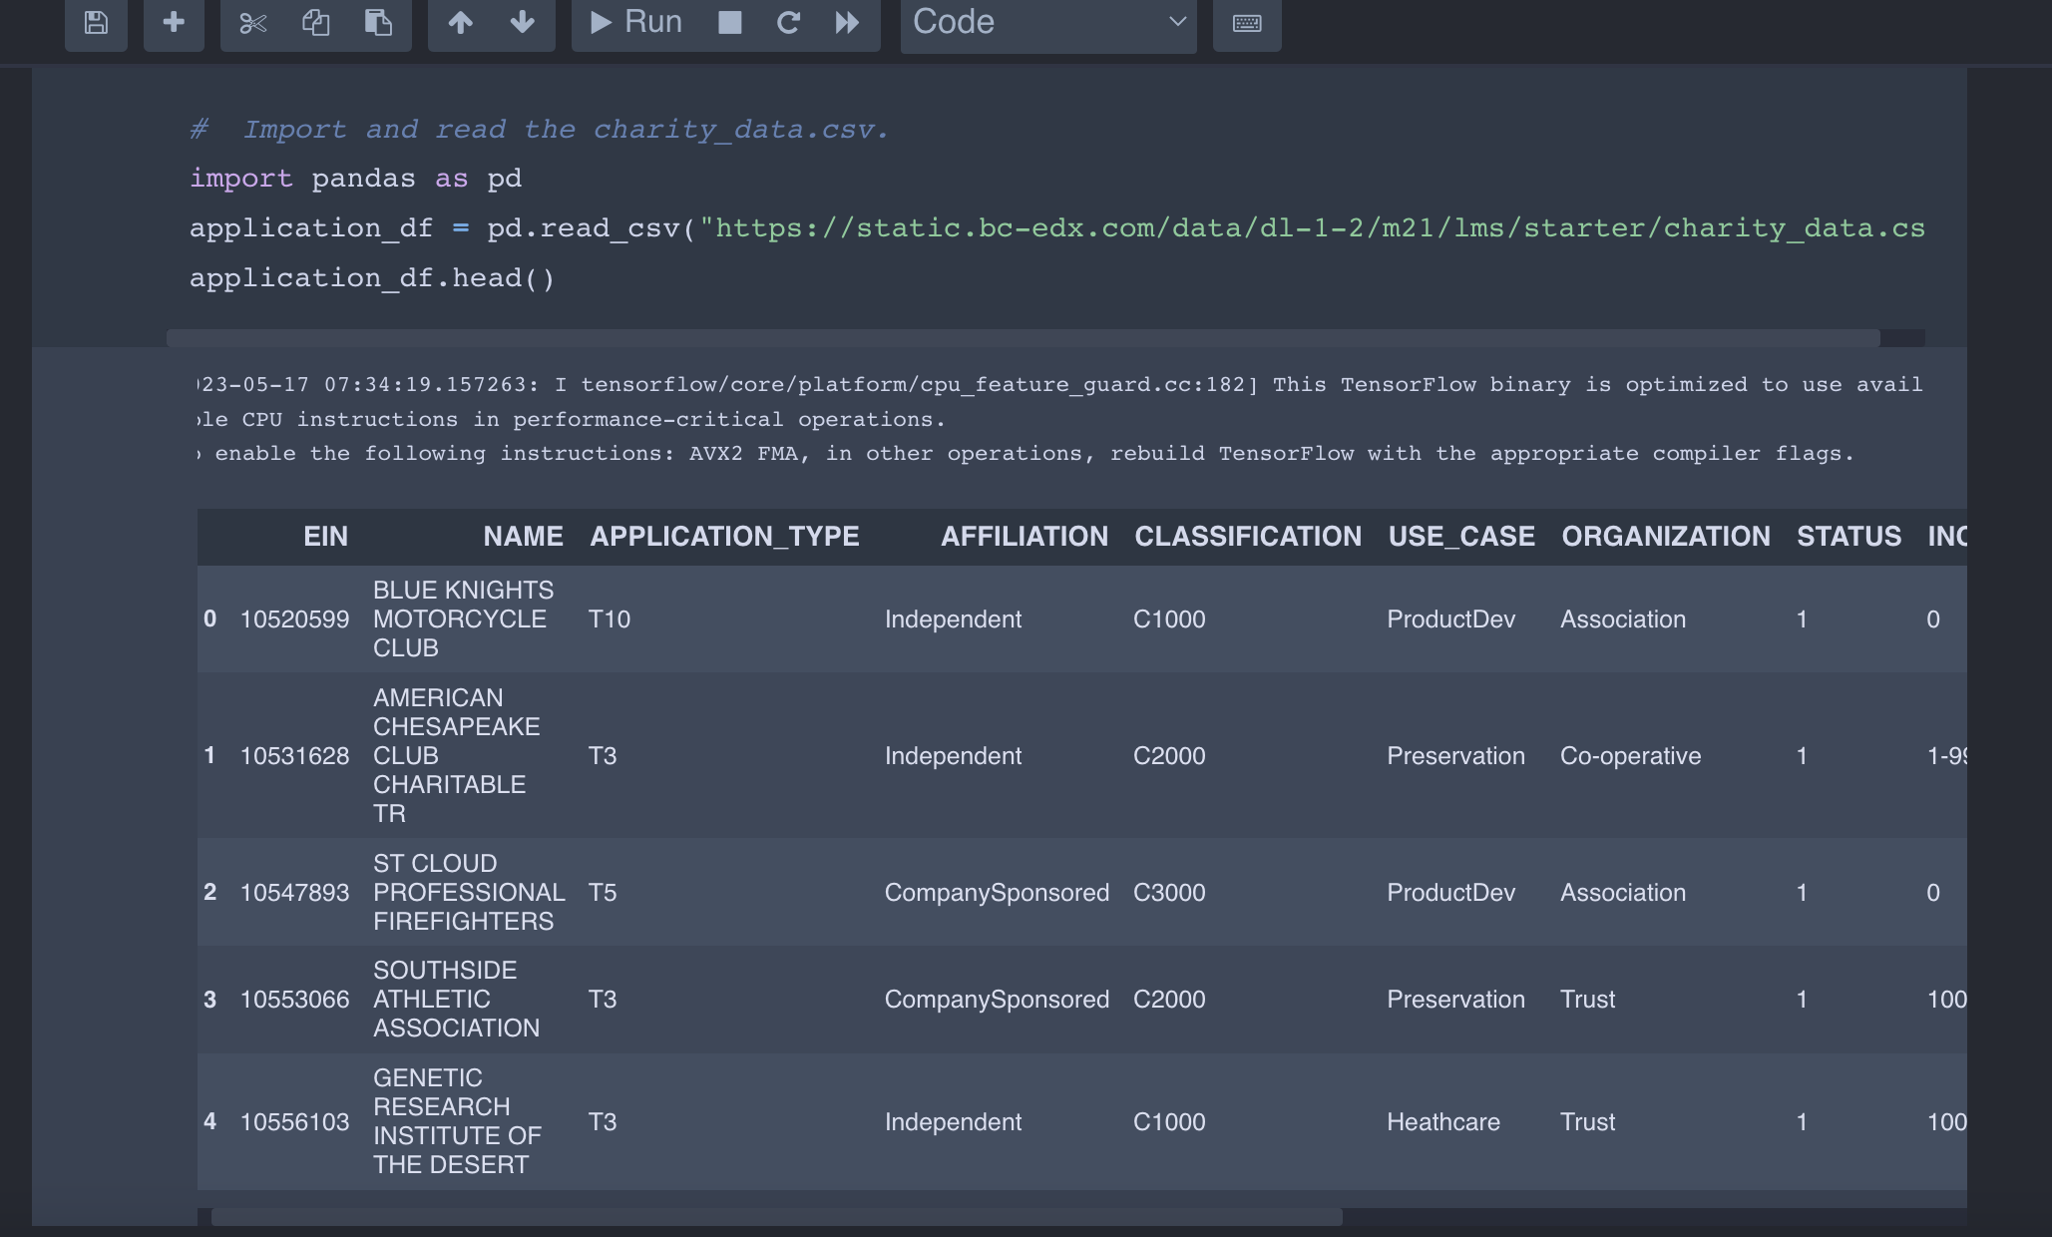

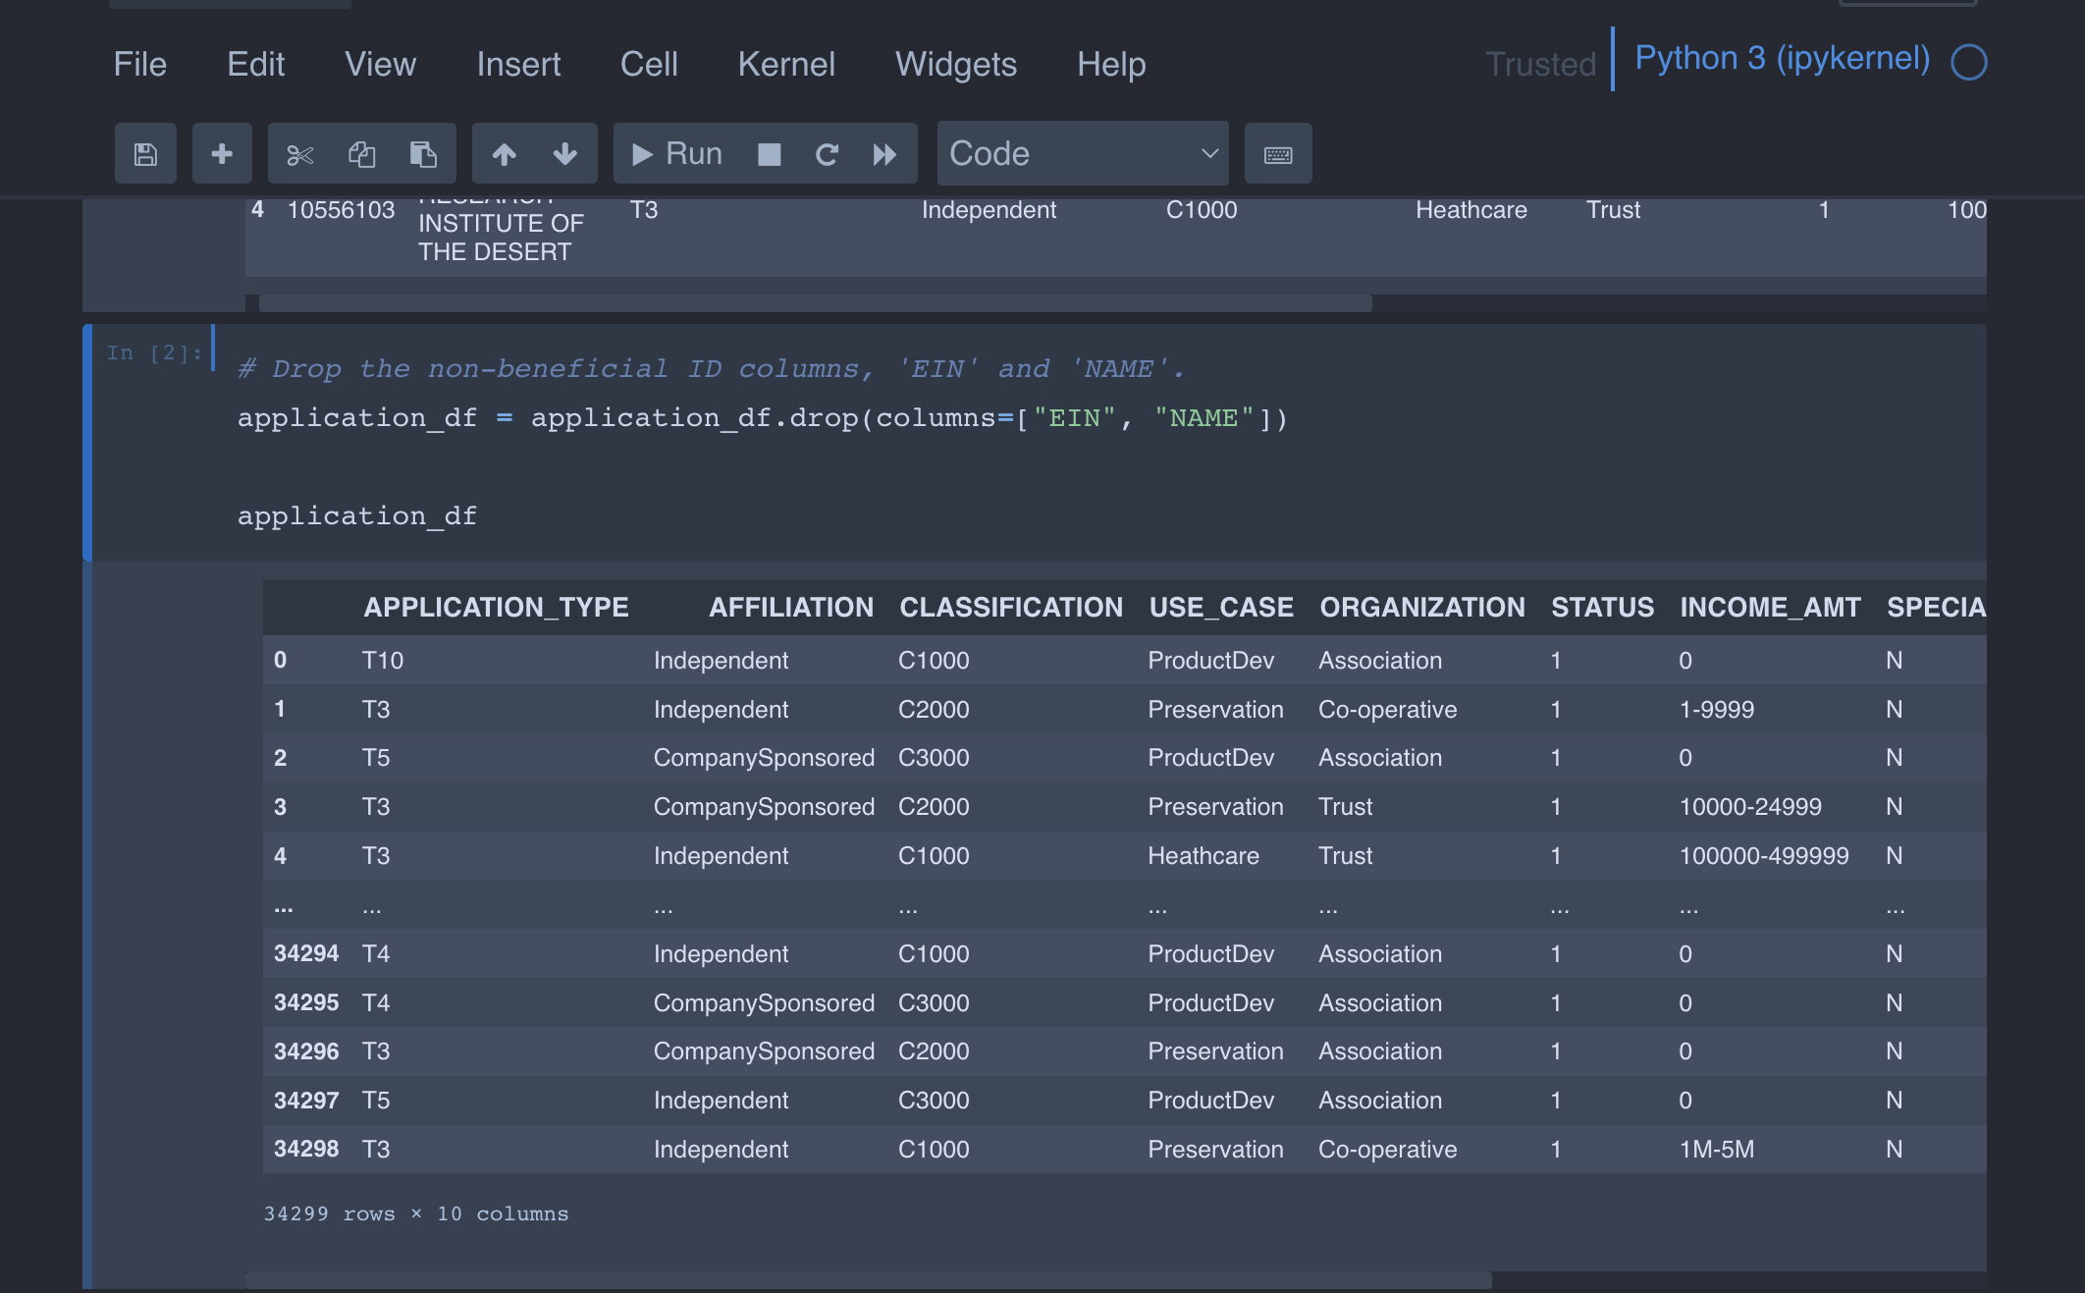

**\* Explain the purpose of the analysis.**

The purpose of the analysis is to use various techniques to train and value a model to predict the chance of an applicant to be successful

**\* Explain what financial information the data was on, and what you needed to predict.**

A nonprofit funding dataset information was provided. and we were asked to analyze the best chance of an applicant to be successful

* Provide basic information about the variables you were trying to predict (e.g., `value counts`).

we were using the variables loan status as a target variable to do the prediction

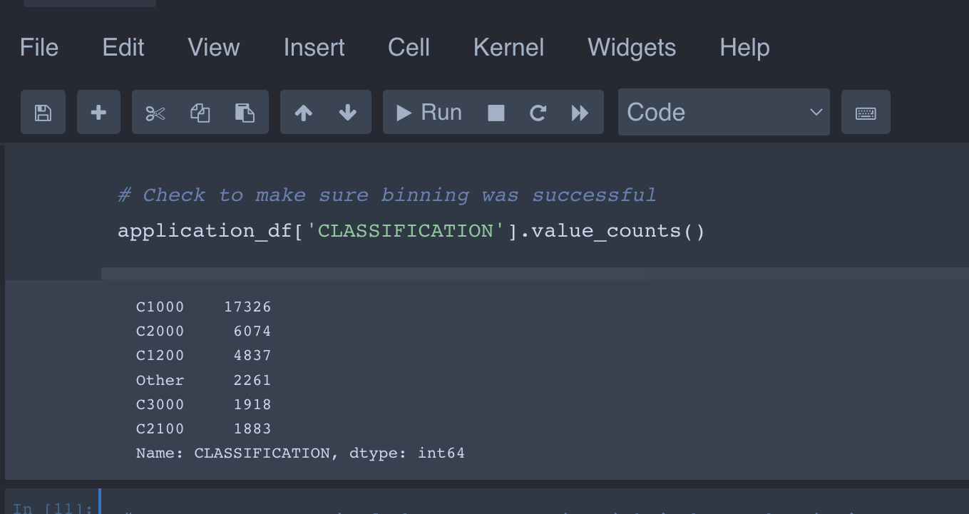

**\* Describe the stages of the machine learning process you went through as part of this** analysis.

to provide this analysis we went through different stage

first, we have the data that was provided for us to be used to train and test the machine learning model, then we prepare the data for analysis, selecting features to be use in the machine learning model, like scaling, normalizing features, converting categorical features into numerical features, then we explore the data to gain a better understanding of the relationship and patterns in the data.

To do our prediction we were using the IS_SUCCESSFUL feature as our target label.

* We split our preprocessed data into our features.
* We split our preprocessed data into a training and testing
* Create a standard scaler
* Fit the standard scaler and then scale

We train and evaluate our model

* To do so, we define the model
* We set our hidden layers
* First hidden layer
* Second hidden layer
* Set the output layer

The set the summary

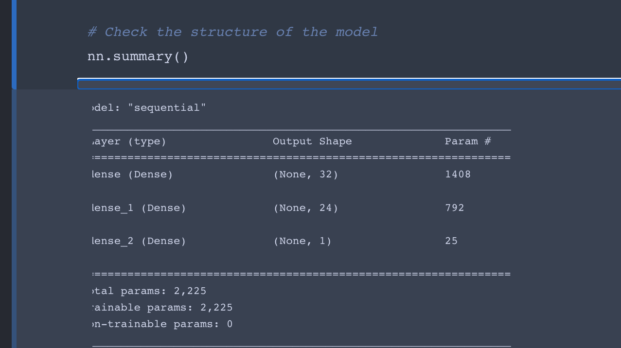

**We trained our model and set the epochs variable to 50**

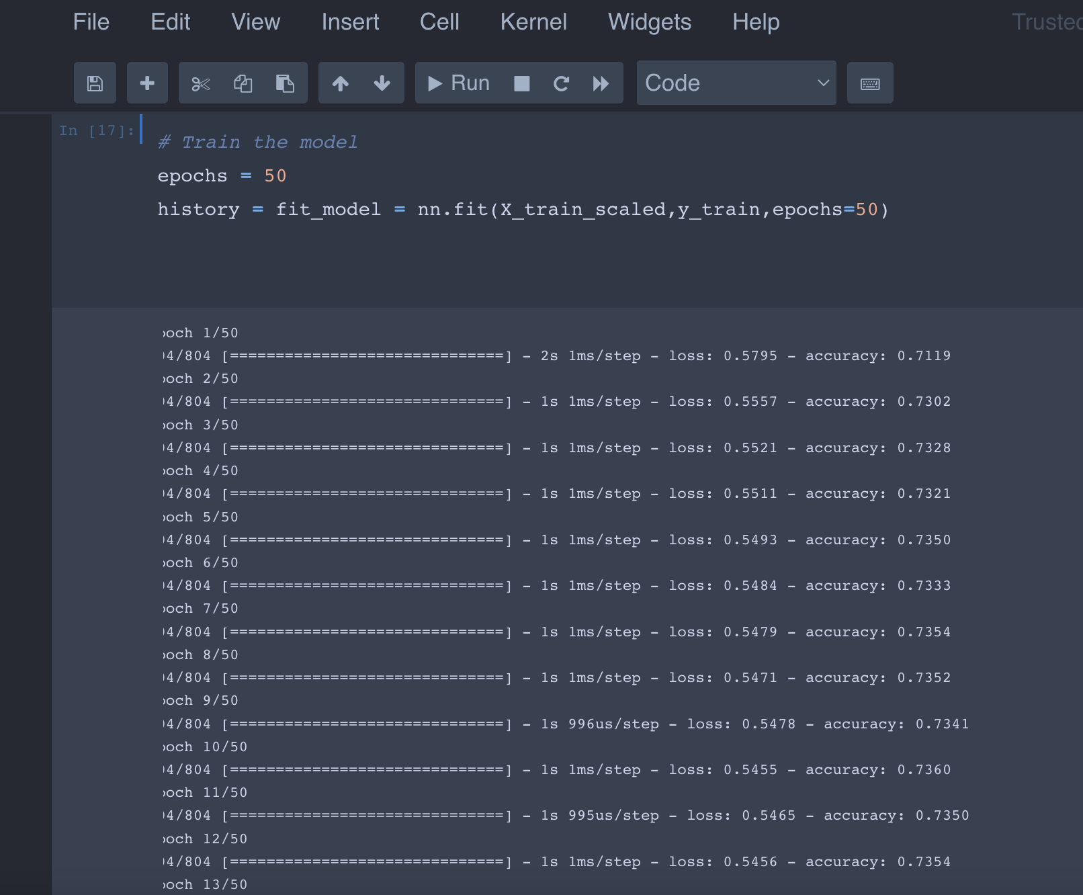

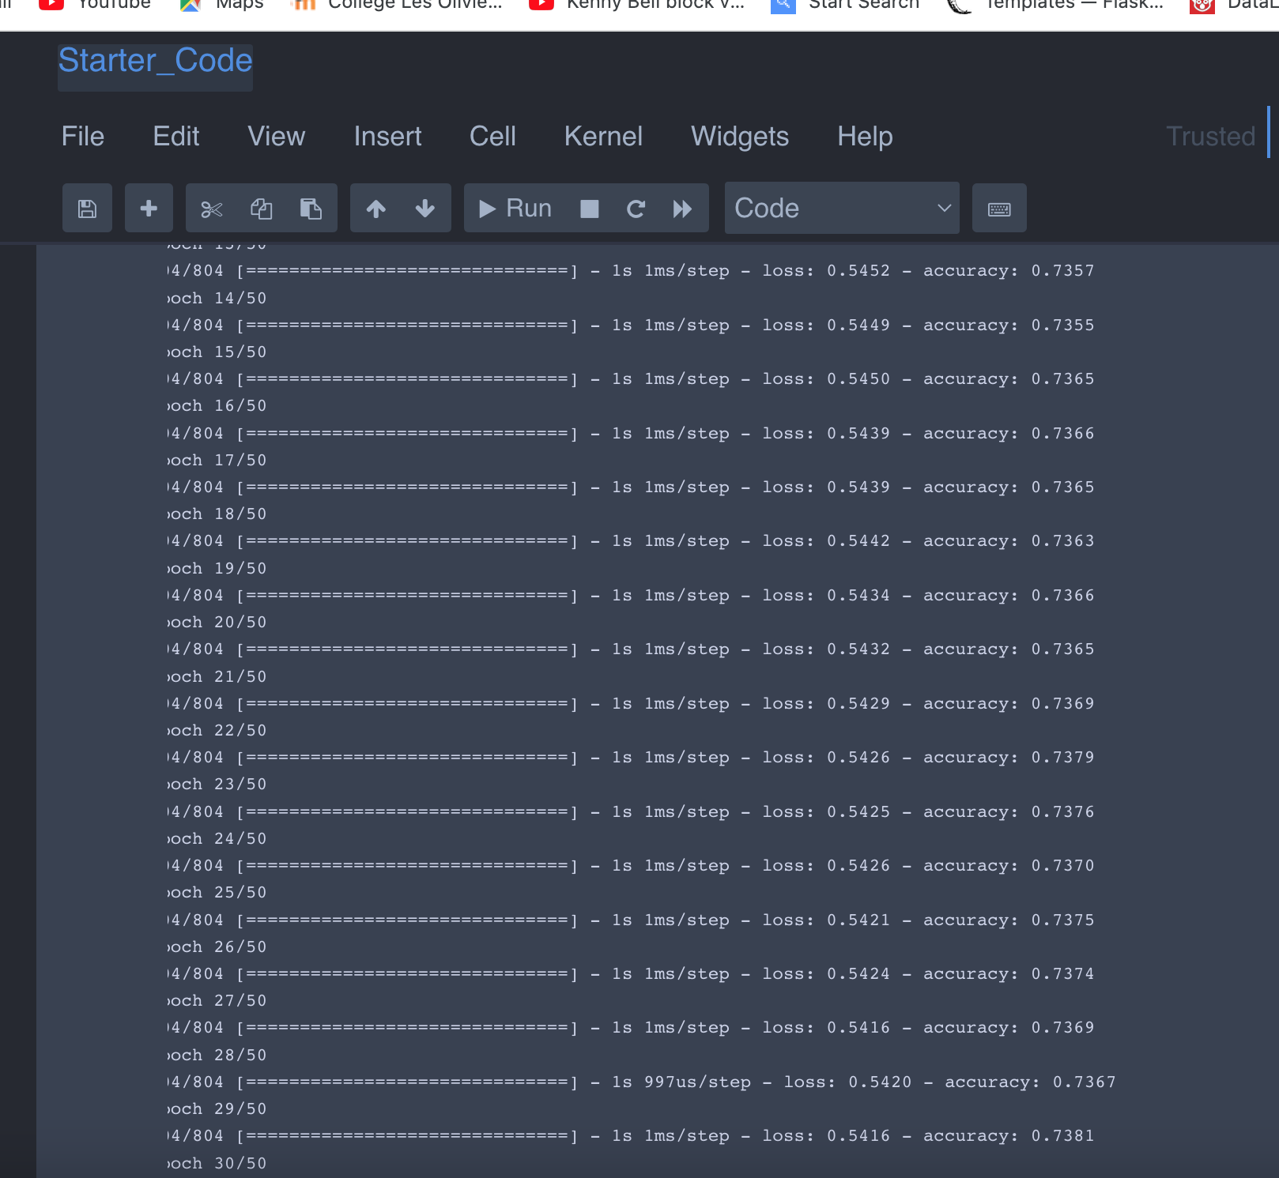

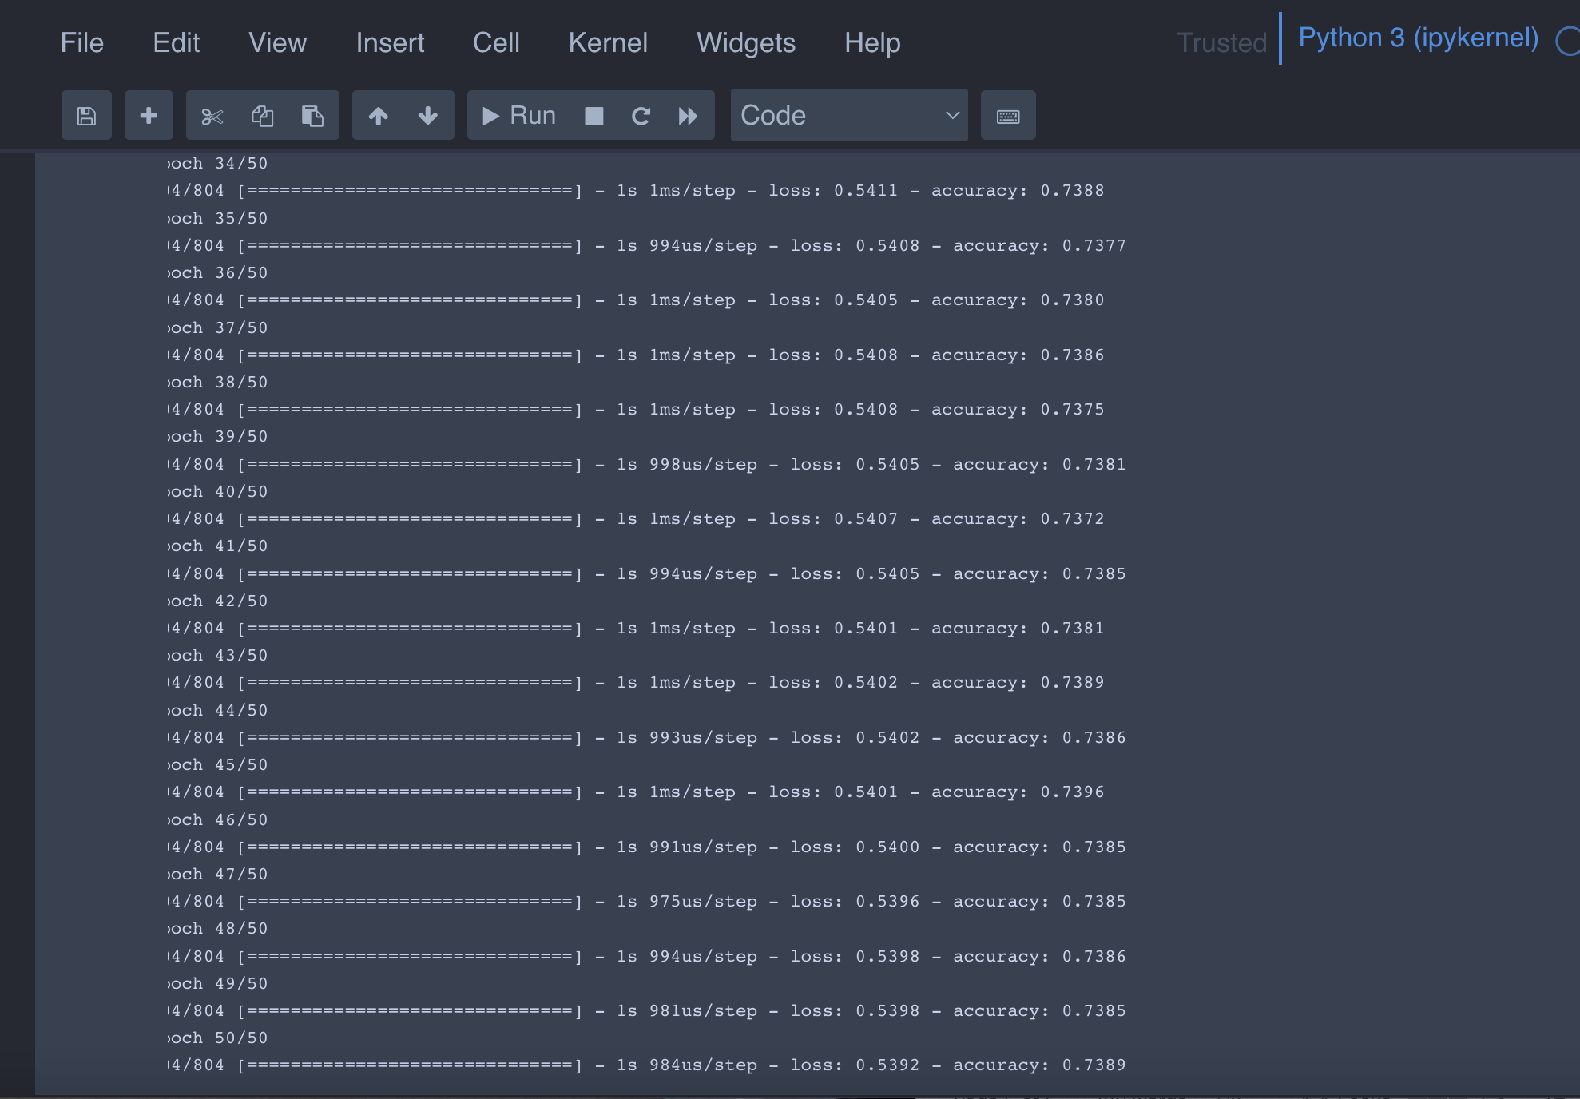

**Then print our final result**

